29.69: At the terminal speed, the upward force 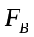 exerted on the loop due to the induced current equals the downward force of gravity: 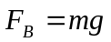
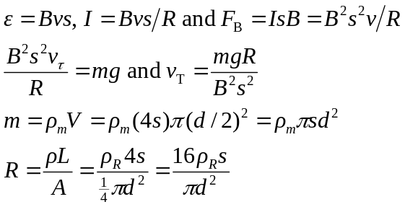
Using these expressions for and gives 